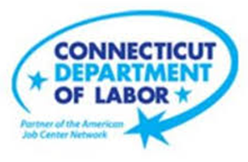

**NEW WEEKLY JOB POSTINGS FROM   
HELP WANTED ONLINE  
Office of Research**

**Week Ending October 29th, 2022: Total Ads Up Slightly Over the Week.**WETHERSFIELD, November 4th, 2022 – During the week ending October 29th, there were 7,334 new postings, up 47 new ads or +0.6% over the week. 12 industries had over the week increases and 9 had decreases. Accommodation & Food Services had the largest increase, up 104 new ads (+36%) and Finance & Insurance had the largest decrease, down -93 new ads (-12%). Within Accommodation & Food Services, the largest employer increase occurred at Chili’s (+24 new ads) over the week and in Finance & Insurance, the largest decreasing employer was Marcum LLP (-26 new ads). The graph below illustrates how the state is down 17% from four weeks ago, which was the highest new ad count since June 2022. Note: The Help Wanted Online data series was revised last month to better reflect job posting behavior on some of its source job board websites. This revision resulted in lower total counts for May-August 2022.  
  
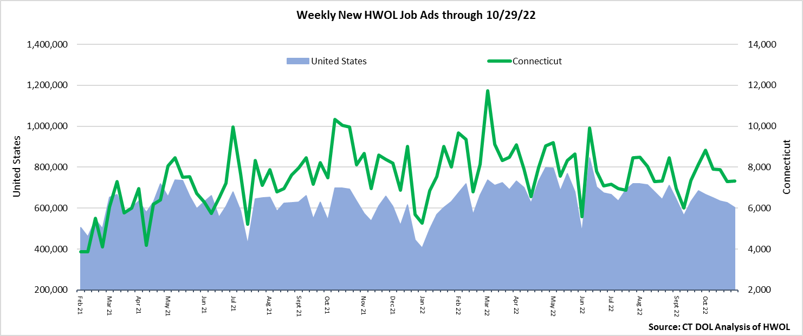  
**Industries** with the most new postings include Health Care & Social Assistance, Retail Trade, and Manufacturing.

**Occupations** with the most new postings include Registered Nurses, Retail Salespersons, and Supervisors of Retail Sales Workers.

**Employers** with the most new postings include Yale-New Haven Health System, Community Health Center, Inc., and Hartford Healthcare.

**The three industries with the most new job postings were:**

* **Health Care & Social Assistance** (1,444 new postings, +2% over the week)
* **Retail Trade** (699 new postings, -6% over the week)
* **Manufacturing** (694 new postings, -0.4% over the week)

  
 During the week ending October 29th, 2022, the slight 0.6% new ad total increase is the net result of increases in 12 industries and declines in 9. The 12 increasing industries grew by a combined 393 new ads and most of that increase occurred in Accommodation & Food Services (+104 new ads) and Educational Services (+97 new ads). The decreasing industries fell by a combined 346 new ads with most of that occurring in Finance & Insurance (-93 new ads) and Pro., Sci., & Tech. Services (-63 new ads). Over four weeks, new ads were down 18% or -1,556 new ads. 15 industries were down, one was unchanged and 5 were up. More than a third of the total four-week decline occurred in Retail Trade  
(-563 new ads). The industries with the largest four week increases were Public Administration and Other Services, both up 23 new ads.  
  
  
 For more information on total job ads by industry for Connecticut and its labor market areas, see the monthly report available here: <https://www1.ctdol.state.ct.us/lmi/hwol.asp>

**New Job Postings by Occupation** 

**The occupations with the most new postings were:**

* Registered Nurses (359 new postings, +13% over the week)
* Retail Salespersons (268 new postings, +18% over the week)
* Supervisors of Retail Sales Workers (150 new postings, -3% over the week)

**Employers with the Most New Job Postings**  Employers with the most new job postings during the week were mostly in Healthcare & Social Assistance, Manufacturing, and Finance & Insurance. The 25 employers shown above account for 19 percent of all new ads. 14 of 25 employers in the top 25 had over-the-week increases and 11 had decreases. The top 25 employers with the largest over the week increase and decreases were Gartner Incorporated. (+80 new ads) and Yale-New Haven Health System   
(-61 new ads) respectively.   
  
**What is HWOL?**The **Conference Board Help Wanted Online**® Data Series (HWOL) measures the number of new, first-time Online job postings and jobs reposted from the previous month for over 16,000 Internet job boards, corporate boards, and smaller job sites that serve niche markets and smaller geographic areas. To view more HWOL data, go to: <https://www1.ctdol.state.ct.us/lmi/hwol.asp>